Use Case model  
FIXED ASSET MANAGEMENT SYSTEM

Version 1.1

Students:

19522455 - Phung Thanh Tu

19520358 - Pham Hieu Vy

19522467 - Le Thanh Tuan

**Document change record sheet**

|  |  |  |  |
| --- | --- | --- | --- |
| **Date** | **Version** | **Description** | **Authors** |
| 03/10/2021 | 1.0 | First product release | Group 15 |
| 03/02/2022 | 1.1 | Update software | Group 15 |

Table of contents

**Use-case diagram** **2**

**Actor List** **3**

**Use-case List** **3**

**Use-case Specification** **3**

Specification of Use-case “Name of Use-case” 3

Short description 3

Flow of events 3

Basic flow 3

Alternative flow 3

Special requirements 4

Pre-condition 4

Post-condition 4

Extend Points 4

# Use-case diagram

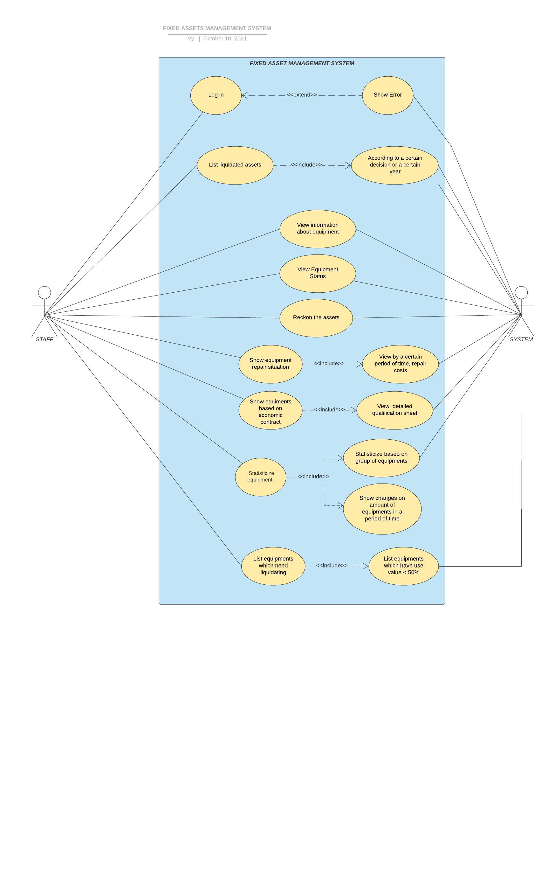

# Actor List

|  |  |  |
| --- | --- | --- |
| .No | Name of Actor | Short description/Notes |
| 1 | Staff | Staff will have permission to all functions that are in the system. |
| 3 | System | System will response all the requests from Staff. |

# Use-case List

|  |  |  |
| --- | --- | --- |
| STT | Name of Use-case | Short desctiption/Notes |
|  | Login | User enter username and password, then login to the system |
|  | List liquidated assets | Show list of liquidated assets based on year or liquidating decision |
|  | **View information about assets** | Show list of assets and their detailed information |
|  | **Show equipment repair situation** | Show equipment repair situation |
|  | **Reckon assets** | Show assets inventory |
|  | **Show equipment based on economic contract** | The use-case begins when staff want to see information about equipment in a certain economic contract. |
|  | **View equipment status** | View use value, detailed status,… of assets |
|  | **Statisticize equipment** | Make statistic about assets |
|  | **List equipments which need liquidating** | List some assets which has use value is less than 50% and thus need liquidating |

# Use-case Specification

***Note: For each Use-case, specify the content of the Use-case according to the following template:***

|  |  |
| --- | --- |
| Name: | **Login** |
| Description: | User enter username and password, then login to the system. |
| Special Requirement: |  |
| Preconditions: | System connected to the Internet  Database is available to verify user’s account |
| Postconditions: |  |
| Normal Flow: | User enter username and password in the corresponding field.  System verify user’s login information.  System grant access to valid user. |
| Alternative Flows: | User enter wrong password or username : Show error and require user to enter again. |
| Extend Points : | When user failed to insert valid information. |

|  |  |
| --- | --- |
| Name: | **View information about assets** |
| Description: | Show list of assets and their detailed information |
| Special Requirement: | User has logged into system. |
| Preconditions: | Database connected. |
| Postconditions: | User can click to menu to use another features. |
| Normal Flow: | System show list of assets which is within management of user’s faculty. |
| Alternative Flows: | If user is in another feature, user have to click on Show List on standard menu so that system can show list of assets. |
| Extend Points : | none |

|  |  |
| --- | --- |
| Name: | **Show equipment repair situation** |
| Description: | Show equipment repair situation |
| Special Requirement: | User has logged into system. |
| Preconditions: | Database connected. |
| Postconditions: | User can click to menu to use another features. |
| Normal Flow: | User click on “Show repair situation” on menu  System show a list of units with their repair situation and fixing bills. |
| Alternative Flows: | none. |
| Extend Points : | none |

|  |  |
| --- | --- |
| Name: | **Reckon assets** |
| Description: | Show assets inventory |
| Special Requirement: | User has logged into system. |
| Preconditions: | Database connected. |
| Postconditions: | User can click to menu to use another features. |
| Normal Flow: | User click on “Show assets reckoning information”  User choose units of which they want to reckon assets.  System show assets inventory of chosen units. |
| Alternative Flows: | none |
| Extend Points : | none |

|  |  |
| --- | --- |
| Name: | **List liquidated assets** |
| Description: | Show list of liquidated assets based on year or liquidating decision |
| Special Requirement: | User has logged into system. |
| Preconditions: | Database connected. |
| Postconditions: | User can click to menu to use another features. |
| Normal Flow: | User click on “Show liquid assets based on” in menu  User choose year/decision  System show information of liquidated assets |
| Alternative Flows: | none |
| Extend Points : | none |

|  |  |
| --- | --- |
| Name: | **Show equipment based on economic contract** |
| Description: | The use-case begins when staff want to see information about equipment in a certain economic contract. |
| Special Requirement: | none |
| Preconditions: | Staff must successfully login to the system.  The economic contract needs to be found in the list of contracts available. |
| Postconditions: | .If the contract needs to be displayed on the list, it will shows the information of the disadvantages in that economic contract |
| Normal Flow: | 1. Search for economic contracts: staff will find a contract to see in the list of existing contracts 2. Display information about equipment in the economic contract |
| Alternative Flows: | Staff can continue to choose other economic contracts: continue showing information about equipment. |
| Extend Points : |  |

|  |  |
| --- | --- |
| Name: | **View equipment status** |
| Description: | The Use-case begins when staff want to see information about usage status of equipment (New equipment or used, the device has been liquidated or not). |
| Special Requirement: | none |
| Preconditions: | Staff must successfully login to the system  Need to have full information about the usage status of all equipment. |
| Postconditions: | .After the selected equipment will display information about their usage status |
| Normal Flow: | 1. Displays a list of available devices: Staff will choose the equipment information section to display them.   Displays equipment status: select the equipment to display their information |
| Alternative Flows: | Staff can continue to choose other equipment: continue showing information about usage status of equipment. |
| Extend Points : | none |

|  |  |
| --- | --- |
| Name: | **Statisticize equipment** |
| Description: | The Use-case begins when staff want to list the number of assets in the whole school, the increase in the number of devices at a certain period of time |
| Special Requirement: |  |
| Preconditions: | Staff must successfully login to the system  The selected group and time need to be available in the system |
| Postconditions: | If Use-case is successfully executed, system will be displayed as a chart to display information details |
| Normal Flow: | Identify the selected group or time to display information  Display information about group assets in groups  Displays information about the increase in the number of equipment according to the specified period of time |
| Alternative Flows: | Staff can continue to choose group or time to display information |
| Extend Points : | none |

|  |  |
| --- | --- |
| Name: | **List equipments which need liquidating** |
| Description: | The Use-case begins when staff want to list properties that need to be liquidated (the remaining use value is less than 50%). |
| Special Requirement: | none |
| Preconditions: | Staff must successfully login to the system  The system must determine the remaining use value of the equipment |
| Postconditions: | If Use-case is successfully executed, The system be displayed the full information of the device on use time |
| Normal Flow: | 1. Select the list of assets to be liquidated: staff will choose the list of assets to display information. 2. The system identifies the equipment with the remaining use value of more than 50% and displays them |
| Alternative Flows: | none |
| Extend Points : | none |